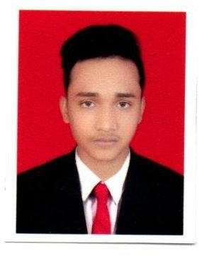**PRIYA BRATA PARIDA Mobile:** 7788826319 / 6372664758

**Email:** [paridapriyabrata49@gmail.co](mailto:%20paridapriyabrata49@gmail.co)m

# CAREER OBJECTIVES

* To have a growth oriented and challenging career, where I can contribute my knowledge and skills to the organization and enhance my experience through continuous learning and teamwork.

# EDUCATION

* **Secondary School Examination,** Session 2015-2016 Form Panchayat High School, Kasananta. Under Board Of Secondary Education, Odisha with Percentage of 60%.
* **Diploma In Civil Engineering,** Session 2016-2019 Form Nilanchal Polytechnic, Bhubaneswar Under

SCTE&VT with percentage of 71%.

* **B. Tech In Civil Engineering**, Session 2019-2022

Form SIT, Bhubaneswar under BPUT

Persuing 8th semester with a percentage of 82%.

# VALUE ADDED COURSES

* + Software known: Auto-CAD, STAAD-PRO.
  + Office Suite: MS-Office



**KEY COMPENTENCIES**

* + Team Spirit
  + Problem Solving Attitude
  + Leadership Quality

# WORKING EXPERIENCE

Working as a QC / Site Inspector in Drillcon Infrastructure Pvt Ltd since Dec, 2022.

**HOBBIES**

* + Playing Cricket
  + Playing Volley Ball

**PERSONAL PROFILE**

* + Date of Birth **:** 1st March 2001
  + Gender **:** Male
  + Nationality **:** Indian
  + Languages Known **:** Odia, English and Hindi

S/o- Sh. Padmaj Bihari Parida

* + Permanent Address At/Po- BilikanaGopalpur, Dis- Kendrapara

State- Odisha Pin- 754215

# DECLARATION

I hereby declare that all the information and facts given above are true to the best of my knowledge and belief.

**DATE**: **PRIYA BRATA PARIDA**

# PLACE: